Experiment No. 2
Aim: Implementation of a given problem statement/s using classes and objects.
- Create a class called Employee that includes three pieces of information as instance variables: first name, last name, and monthly salary. Your class should have a constructor that initializes the three instance variables. Provide a setter and getter method for each instance variable. If the monthly salary is not positive, set it to 0.0. Write a test application named EmployeeTest that demonstrates the Employee class's capabilities. Create two Employee objects and display each object's yearly salary. Then give each Employee a 10% raise and display each Employee's yearly salary again.

public class EmployeeTest {
static class Employee {
private String firstName;
private String lastName;
private double monthlySalary;

public Employee(String firstName, String lastName, double monthlySalary) {
this.firstName = firstName;
this.lastName = lastName;
if (monthlySalary > 0)
this.monthlySalary = monthlySalary;
else
this.monthlySalary = 0.0;
}
public void setFirstName(String firstName) {
this.firstName = firstName;
}
public String getFirstName() {
return firstName;
}
public void setLastName(String lastName) {
this.lastName = lastName;
}
public String getLastName() {
return lastName;
}
public void setMonthlySalary(double monthlySalary) {
if (monthlySalary > 0)
this.monthlySalary = monthlySalary;
else
this.monthlySalary = 0.0;
}
public double getMonthlySalary() {
return monthlySalary;
}
public double getYearlySalary() {
return monthlySalary * 12;
}
}

public static void main(String[] args) {
Employee e1 = new Employee("Prasanna", "Bhurke", 20000);
Employee e2 = new Employee("Rahul", "Sharma", 25000);

System.out.println(e1.getFirstName() + " yearly salary: " + e1.getYearlySalary());
System.out.println(e2.getFirstName() + " yearly salary: " + e2.getYearlySalary());

e1.setMonthlySalary(e1.getMonthlySalary() * 1.10);
e2.setMonthlySalary(e2.getMonthlySalary() * 1.10);

System.out.println("After 10% raise:");

System.out.println(e1.getFirstName() + " yearly salary: " + e1.getYearlySalary());
System.out.println(e2.getFirstName() + " yearly salary: " + e2.getYearlySalary());
}
}

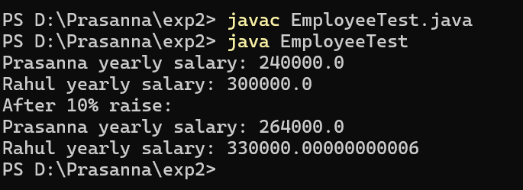

- Implement a Java program to print the area of a rectangle by creating a class named 'Area' that has two methods. The first method, named 'setDim', takes the length and breadth of the rectangle as parameters. The second method, named 'getArea', returns the area of the rectangle. The length and breadth of the rectangle are entered through the keyboard
import java.util.Scanner;
public class Area {
private double length;
private double breadth;
public void setDim(double length, double breadth) {
this.length = length;
this.breadth = breadth;
}
public double getArea() {
return length * breadth;
}
public static void main(String[] args) {
Scanner sc = new Scanner(System.in);
Area rect = new Area();
System.out.print("Enter length: ");
double l = sc.nextDouble();
System.out.print("Enter breadth: ");
double b = sc.nextDouble();
rect.setDim(l, b);
System.out.println("Area of rectangle: " + rect.getArea());
sc.close();
}
}

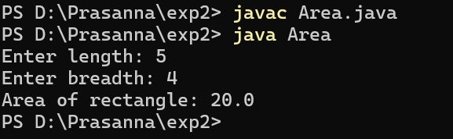

- Write a Java program to demonstrate the use of static variables, static blocks, and static methods

public class StaticDemo {
static int count;
static String message;
static {
count = 0;
message = "Static block executed";
System.out.println(message);
}
public StaticDemo() {
count++;
}
static void showCount() {
System.out.println("Objects created: " + count);
}
public static void main(String[] args) {
StaticDemo s1 = new StaticDemo();
StaticDemo s2 = new StaticDemo();
StaticDemo.showCount();
}
}
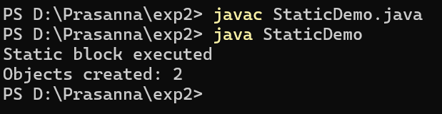

- Write a Java program to implement a stack and a queue.

import java.util.Scanner;
class Stack {
int[] arr;
int top;
Stack(int size) {
arr = new int[size];
top = -1;
}
void push(int x) {
if (top == arr.length - 1)
System.out.println("Stack Overflow");
else
arr[++top] = x;
}
void pop() {
if (top == -1)
System.out.println("Stack Underflow");
else
System.out.println("Popped: " + arr[top--]);
}
void display() {
if (top == -1)
System.out.println("Stack Empty");
else {
for (int i = top; i >= 0; i--)
System.out.print(arr[i] + " ");
System.out.println();
}
}
}
class Queue {
int[] arr;
int front, rear;

Queue(int size) {
arr = new int[size];
front = 0;
rear = -1;
}
void enqueue(int x) {
if (rear == arr.length - 1)
System.out.println("Queue Overflow");
else
arr[++rear] = x;
}
void dequeue() {
if (front > rear)
System.out.println("Queue Underflow");
else
System.out.println("Deleted: " + arr[front++]);
}
void display() {
if (front > rear)
System.out.println("Queue Empty");
else {
for (int i = front; i <= rear; i++)
System.out.print(arr[i] + " ");
System.out.println();
}
}
}
public class Main {
public static void main(String[] args) {
Scanner sc = new Scanner(System.in);

Stack stack = new Stack(5);
Queue queue = new Queue(5);

while (true) {
System.out.println("1.Push 2.Pop 3.Display Stack");
System.out.println("4.Enqueue 5.Dequeue 6.Display Queue 7.Exit");
int ch = sc.nextInt();

switch (ch) {
case 1:
stack.push(sc.nextInt());
break;
case 2:
stack.pop();
break;
case 3:
stack.display();
break;
case 4:
queue.enqueue(sc.nextInt());
break;
case 5:
queue.dequeue();
break;
case 6:
queue.display();
break;
case 7:
sc.close();
return;
default:
System.out.println("Invalid choice");
}
}
}
}

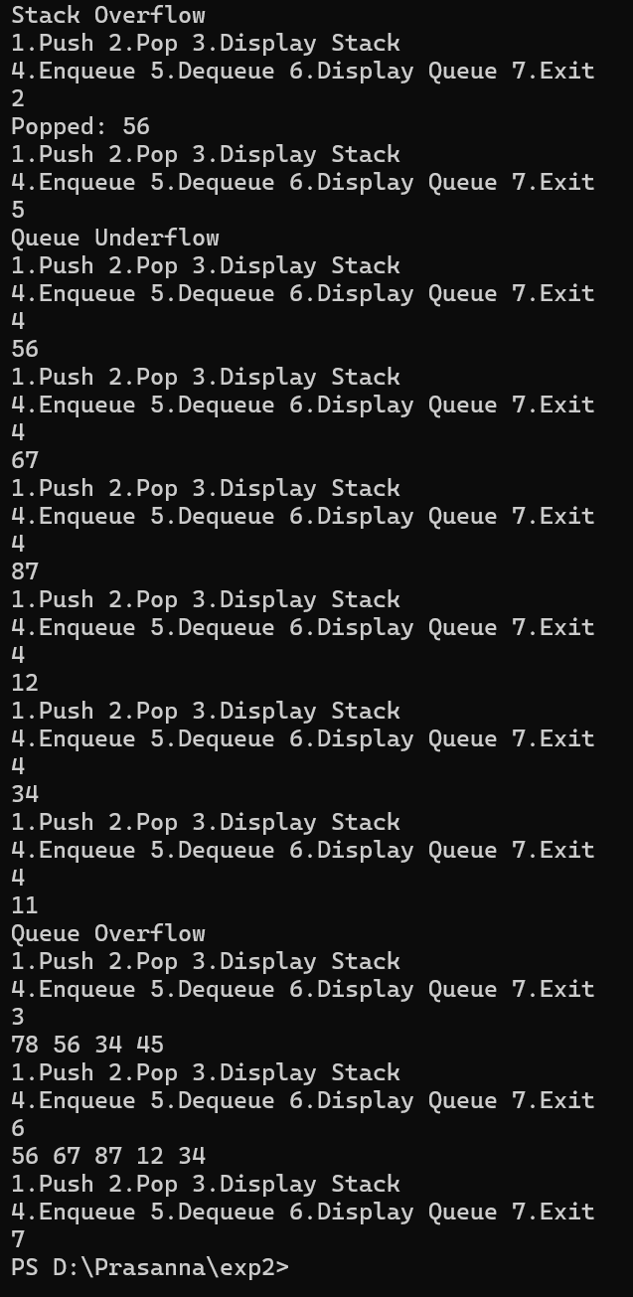
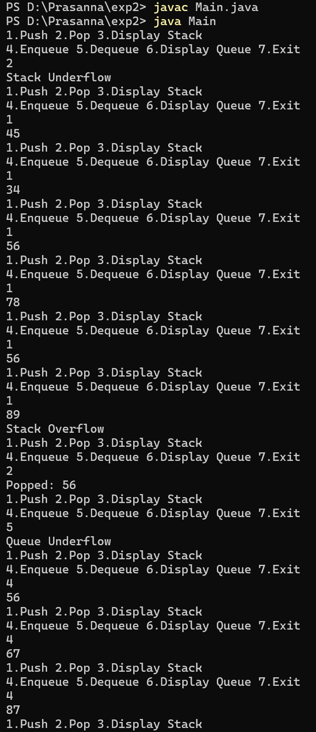

- Write a Java program to arrange 10 names in alphabetical order.
import java.util.Scanner;
public class SortNames {
public static void main(String[] args) {
Scanner sc = new Scanner(System.in);
String[] names = new String[10];
System.out.println("Enter 10 names:");
for (int i = 0; i < 10; i++)
names[i] = sc.nextLine();
for (int i = 0; i < names.length - 1; i++)
for (int j = 0; j < names.length - 1 - i; j++)
if (names[j].compareToIgnoreCase(names[j + 1]) > 0) {
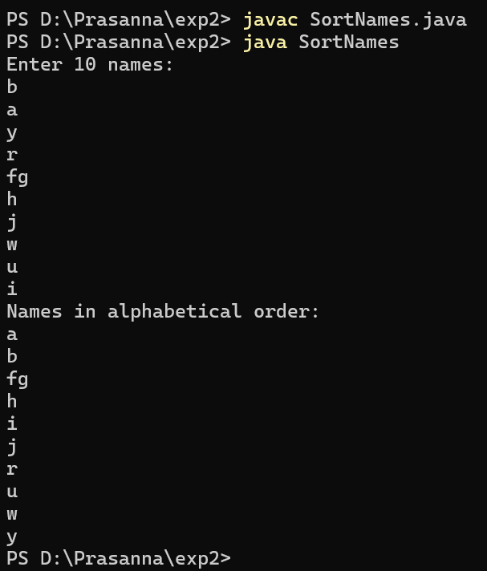
String temp = names[j];
names[j] = names[j + 1];
names[j + 1] = temp;
}
System.out.println("Names in alphabetical order:");
for (String name : names)
System.out.println(name);
sc.close();
}
}

